Ibrahim's Bharosa Wallet| kyun k Hamain hai khyaal apkay bharosay ka! |

No. | Test Case | Action Performed | Expected Outcome | Observed Result | Pass/Fail
1 | Input Validation – SQL Injection | Entered ' OR 1=1 -- in login form | Input rejected / error handled | [Invalid credentials" (no login bypass).  ] | [Pass]
2 | Password Strength | Tried weak password 12345 | Rejected | [Error "Password must be 8+ chars, with digit and symbol."  ] | [Pass]
3 | Special Character Input | Added <script> in username | Sanitized / rejected | [Escaped output, no XS] | [Pass]
4 | Unauthorized Access | Opened dashboard without login | Redirected to login | [Access blocked  ] | [Pass]
5 | Session Expiry | Idle for 5 minutes | Auto logout | [Session expired  ] | [Pass]
6 | Logout Functionality | Pressed logout | Session destroyed | [Redirect to login] | [Pass]
7 | Data Confidentiality | Opened stored DB file | Passwords hashed | [Secure storage (hashed)  ] | [Pass]
8 | File Upload Validation | Tried uploading .exe file | File rejected | [Only .txt or .pdf allowed  ] | [Pass]
9 | Error Message Leakage | Entered invalid query | Generic error | [No stack trace  ] | [Pass]
10 | Input Length Validation | Entered 5000 chars in field | Validation triggered | [Safe handling  ] | [Pass]
11 | Duplicate User Registration | Tried existing username | Error displayed | [Correct handling.  ] | [Pass]
12 | Number Field Validation | Entered letters in amount field | Rejected | [Validation successful  ] | [Pass]
13 | Password Match Check | Mismatched confirm password | Registration blocked | [Correct  ] | [Pass]
14 | Data Modification Attempt | Changed transaction ID manually | Access denied | [] | [Pass/Fail]
15 | Email Validation | Entered abc@ | Error shown | [Invalid email format] | [Pass]
16 | Login Attempt Lockout | 5 failed logins | Account locked | [Lockout triggered  ] | [Pass]
17 | Secure Error Handling | Forced divide-by-zero | App didn’t crash |  | [Pass/Fail]
18 | Encrypted Record Check | Viewed stored data file | Data unreadable | [Encrypted  ] | [Pass]
19 | Input Encoding | Used Unicode emoji input | App handled gracefully | [] | [Pass/Fail]
20 | Empty Field Submission | Left fields blank | Warning displayed | [Invalid credentials  ] | [Pass]
Scenario 1: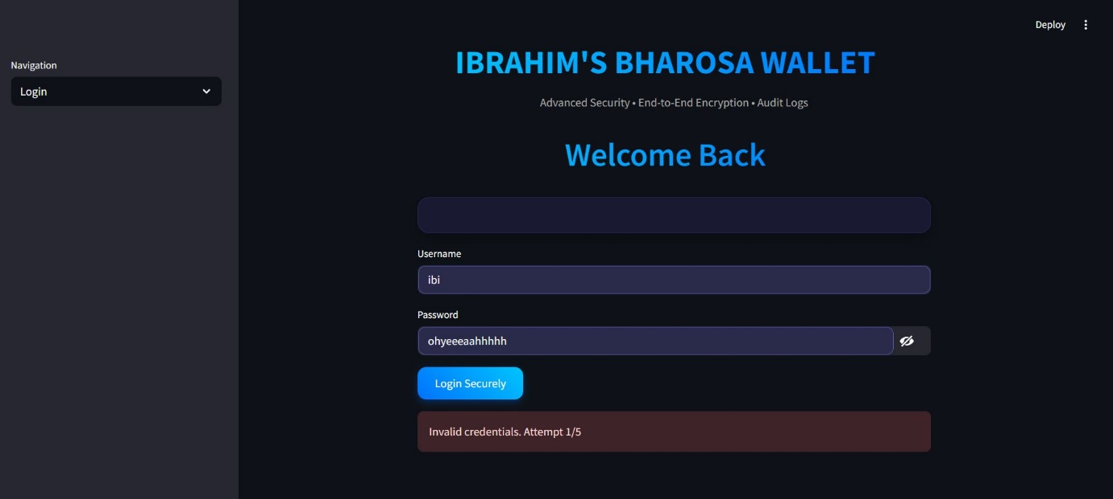
Scenario2: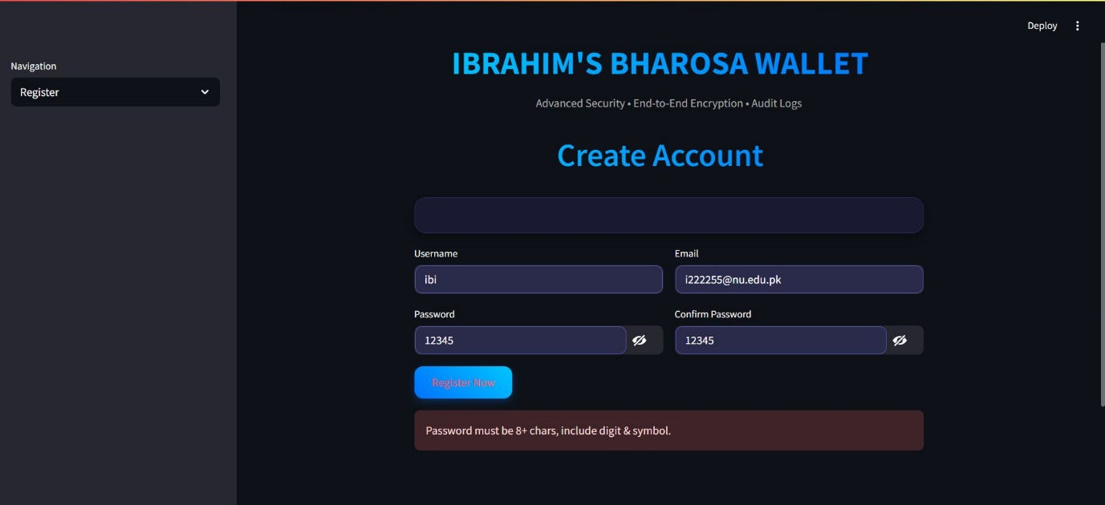
Scenario3: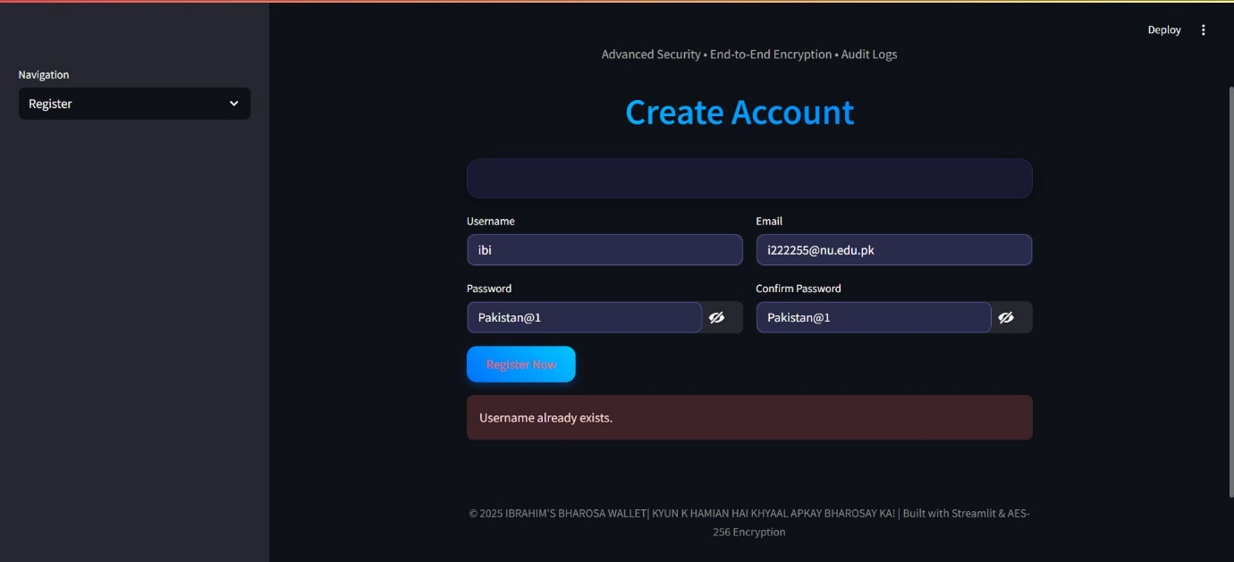
Scenario4: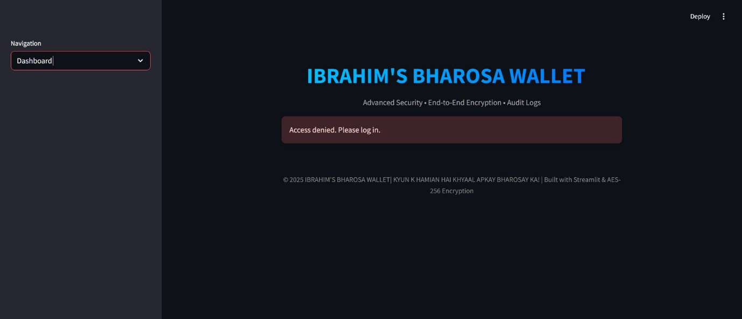
Scenario5: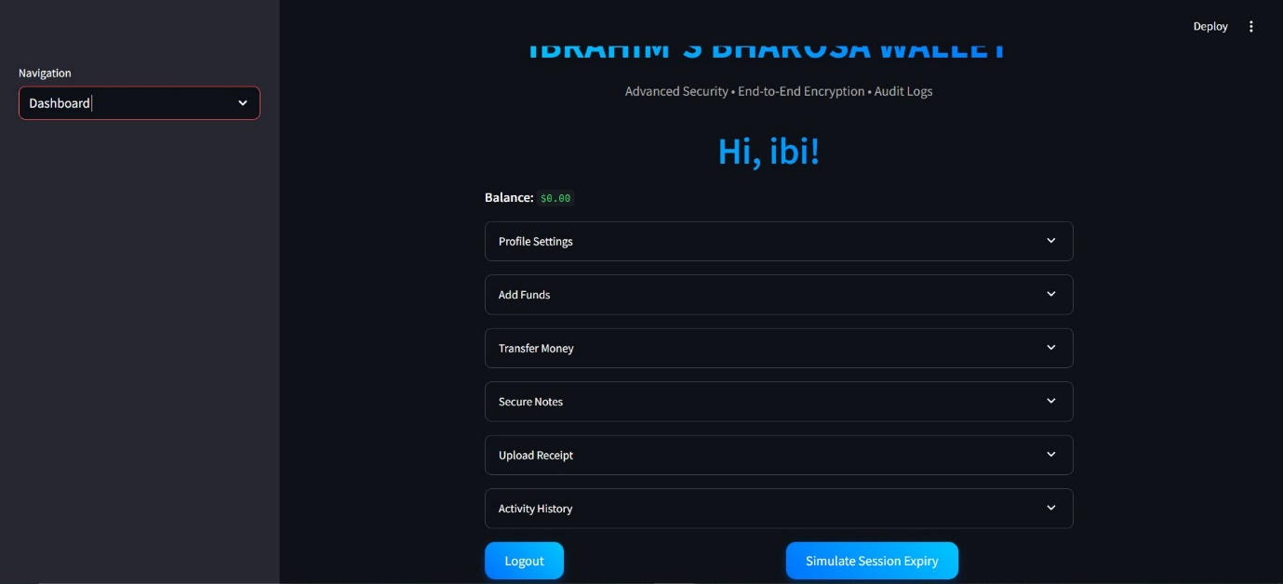
Scenario 6:
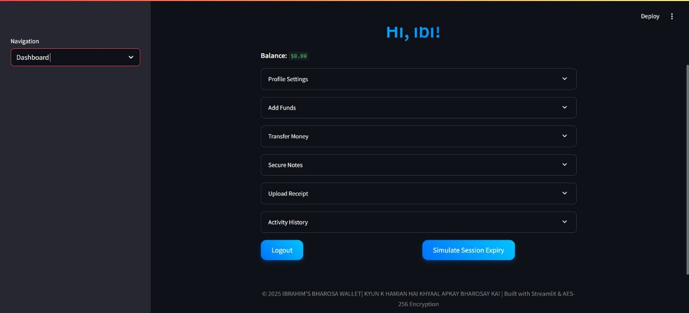
Scenario 7:
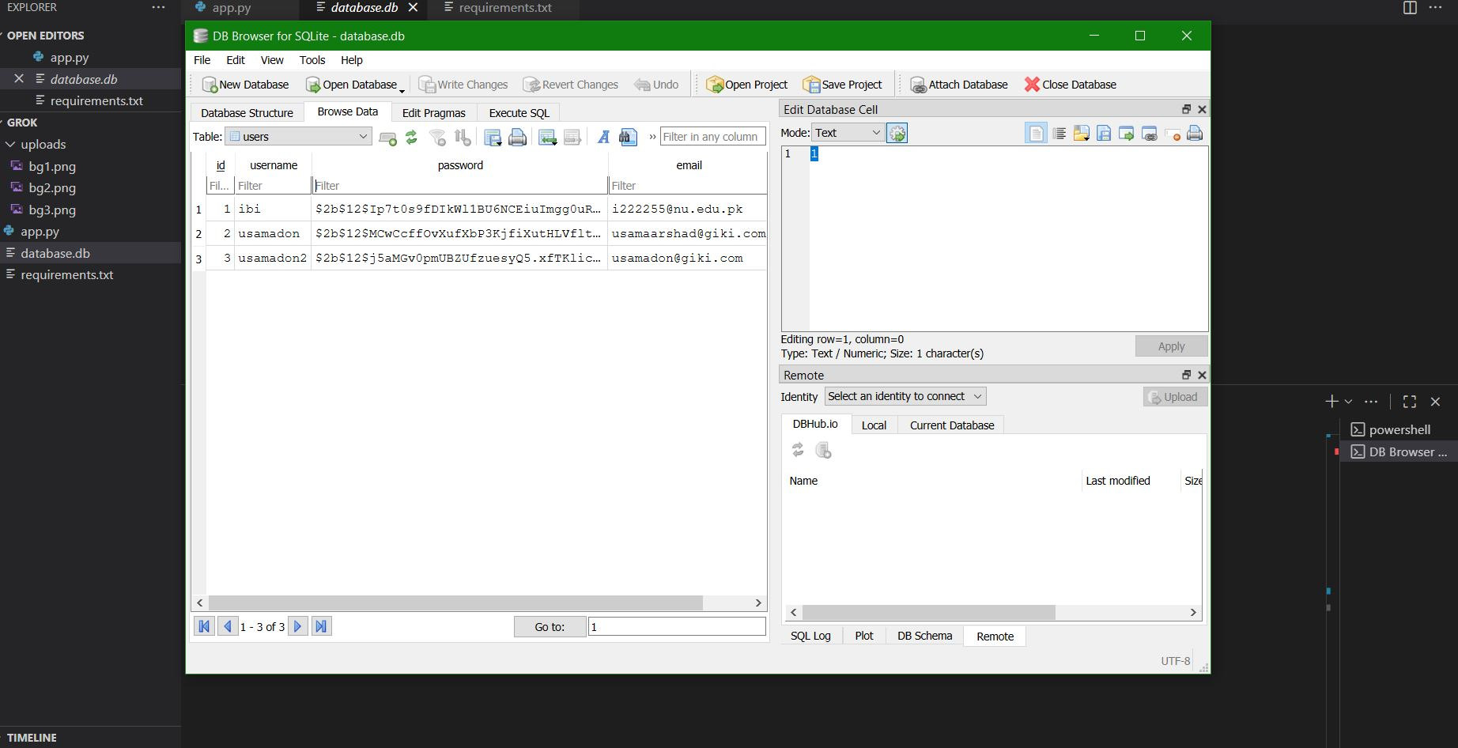
Scenario 8:
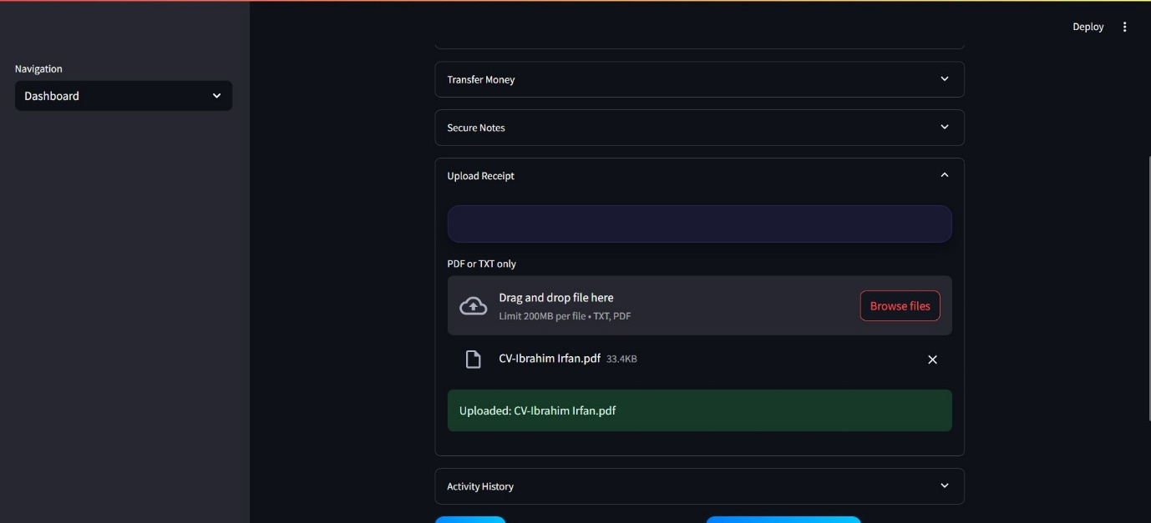
Scenario 9:
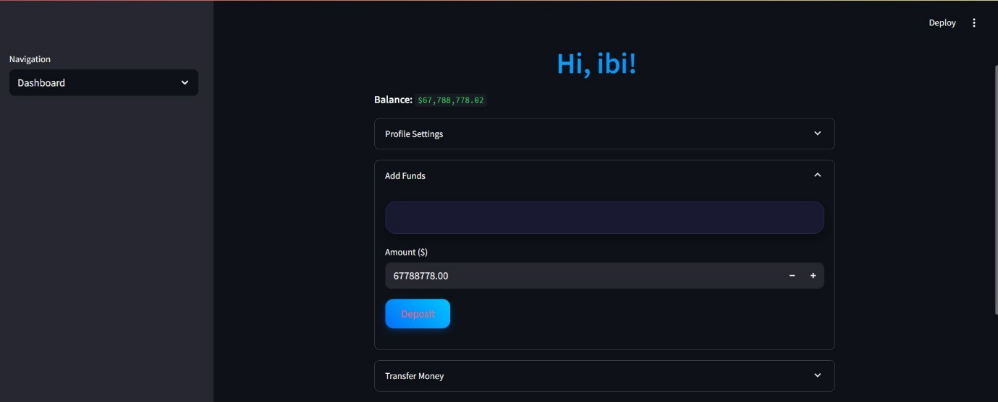
Scenario 10:
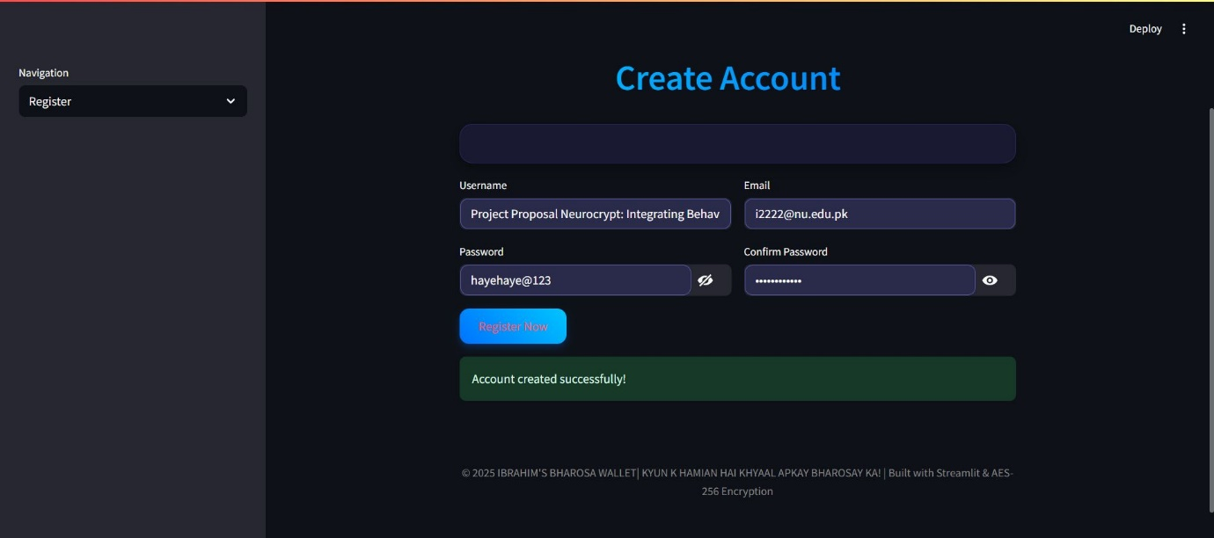
Scenario 11:
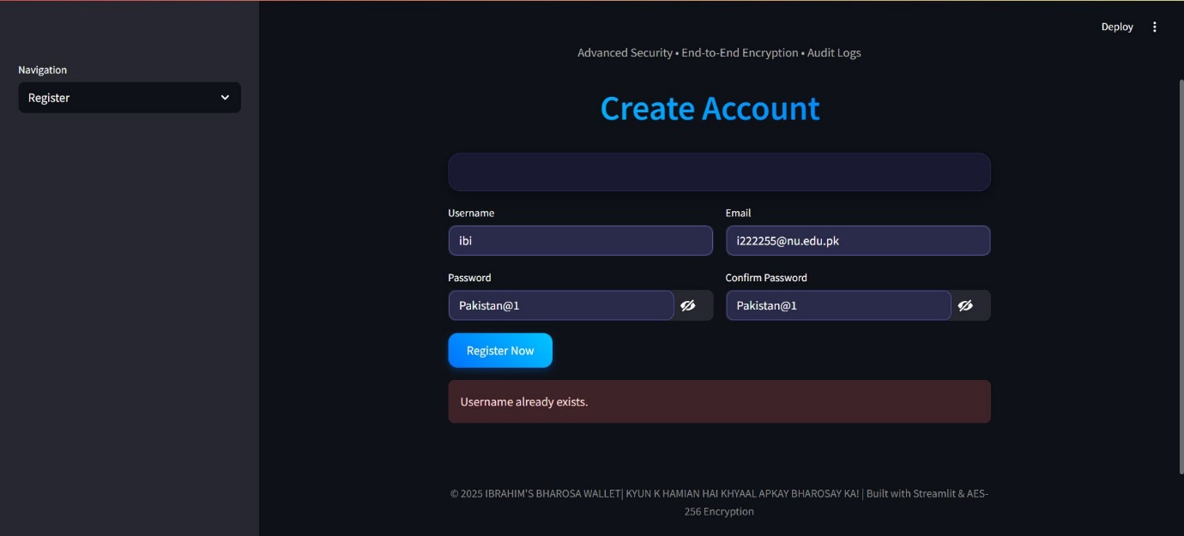
Scenario 12:
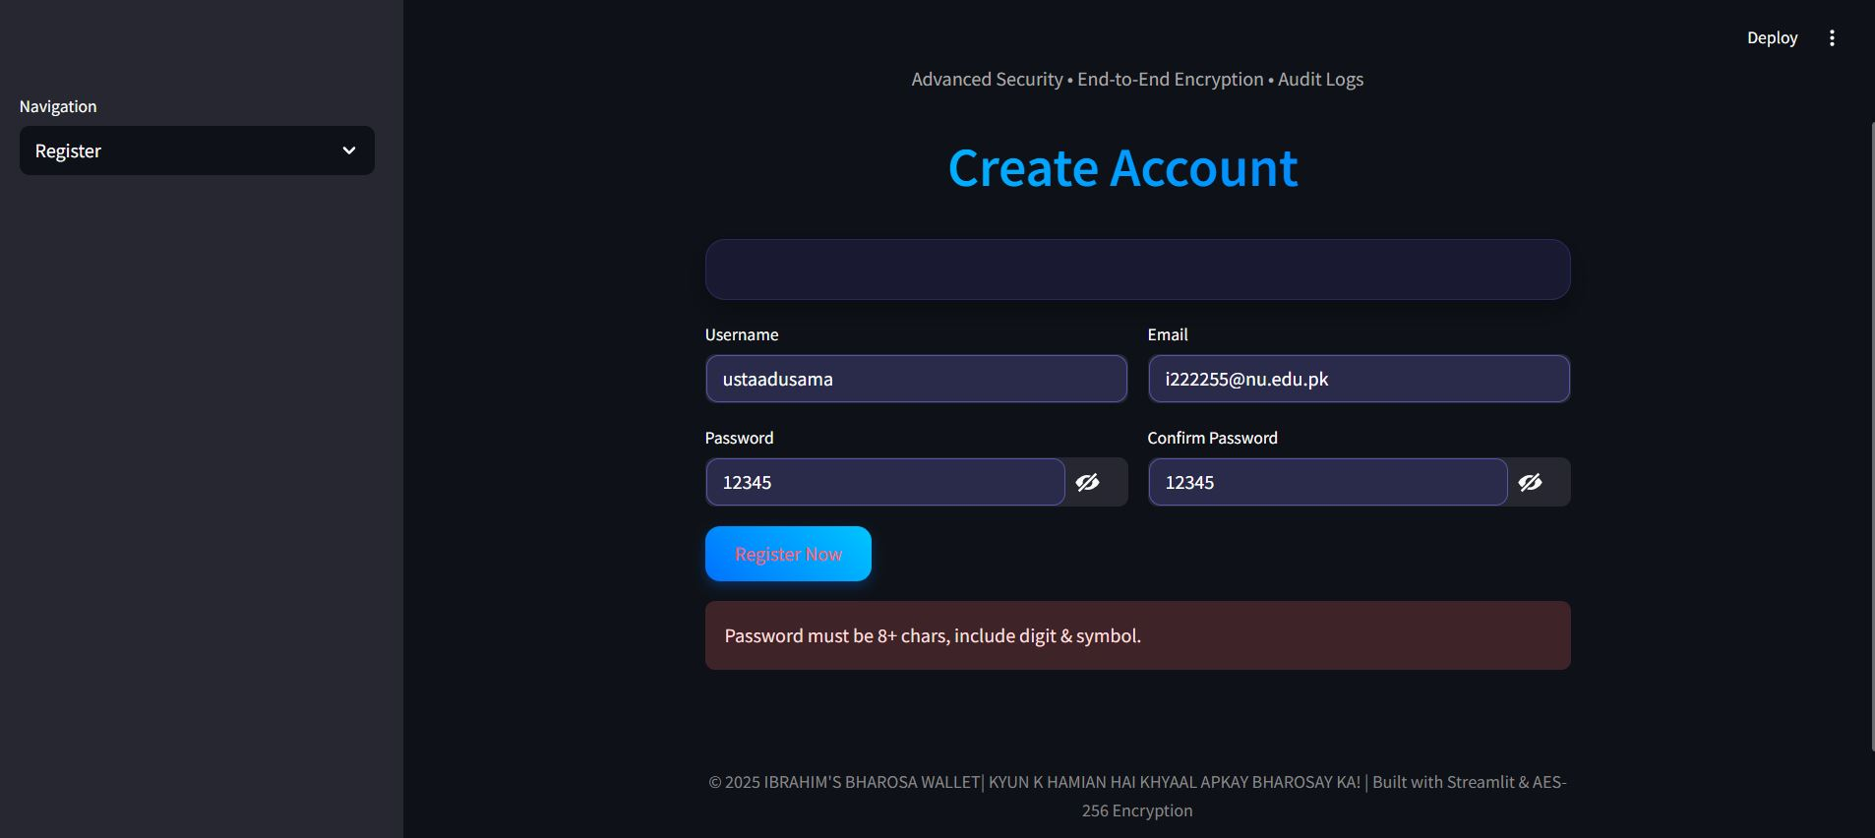
Scenario 13: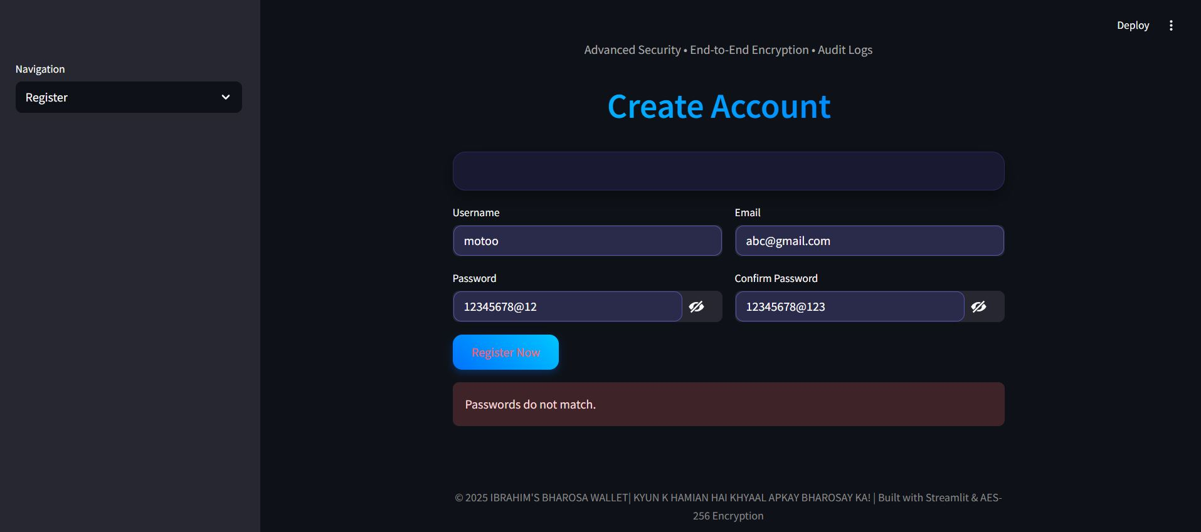
Scenario 15: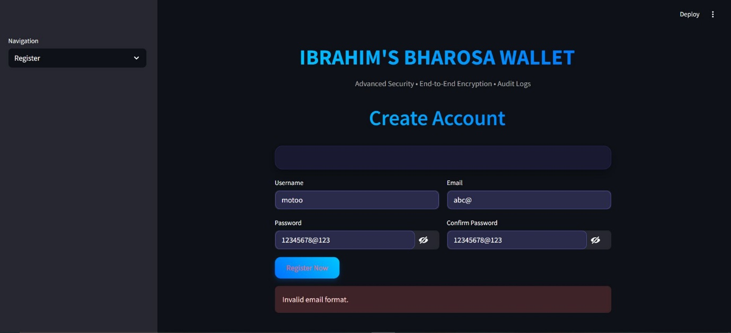
Scenario 16:
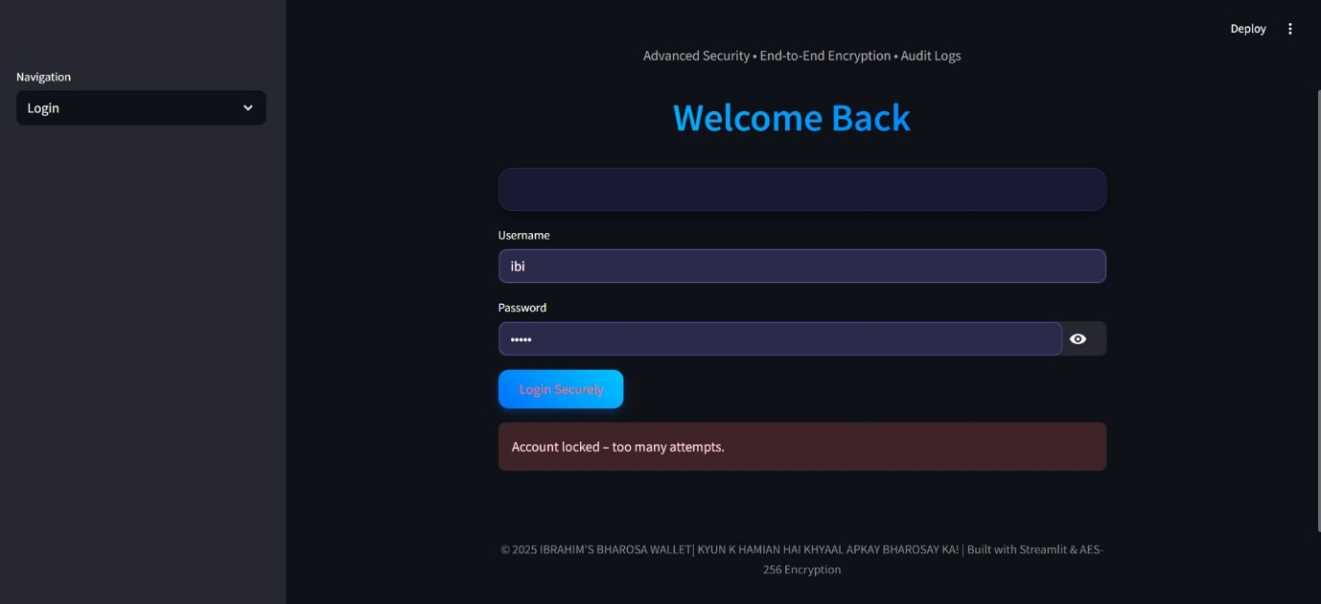
Scenario 18:
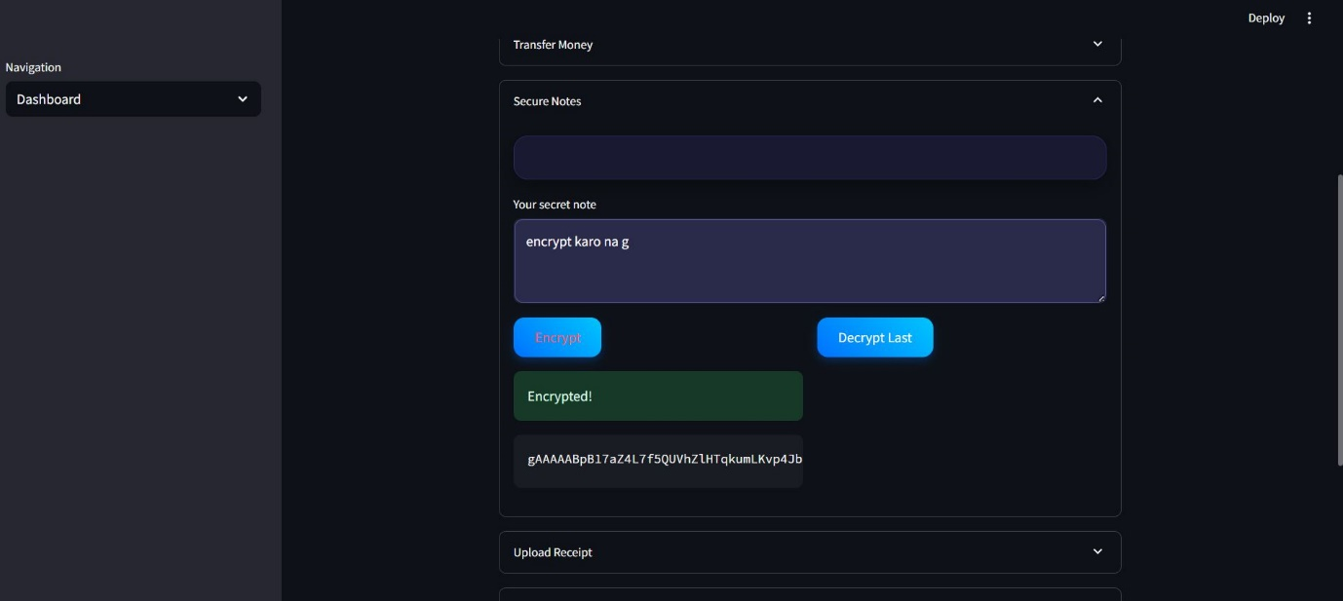
Scenario 20:
